Robot Operating System (ROS) and CRCL Integration

Michaloski, John L.

2/11/2016 12:12:18 PM

You select a robot model, and then run a launch file using a URDF file describing this robot, and it launches a RVIZ, Joint Move GUI and diagnostic output.

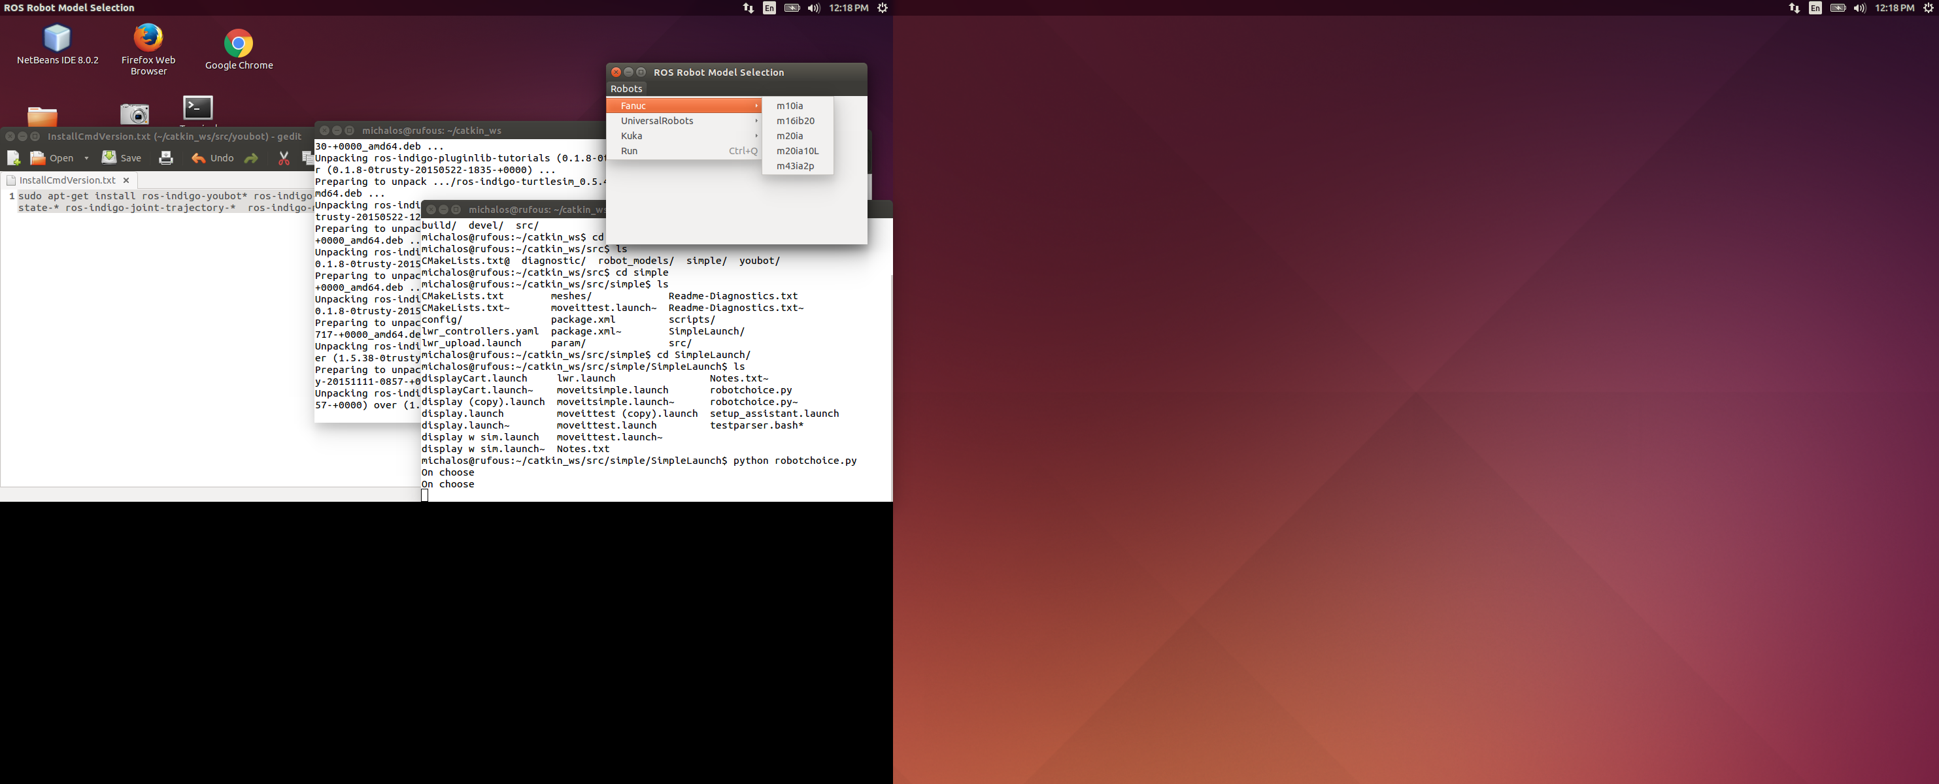



Legend:

/xxx – topic xxx









## Making CRCL Work with Java CRCL Client

Notes, tcpdump must be run as super user, or you will get error. Note the windows grandfloria ip address is 129.6.33.112.

TCPDUMP: for snooping on local host with Java CRCL Server/Client

sudo tcpdump -i lo port 64444 -w localhostdump.txt

TCPDUMP: for snooping on remote host running xerces/codesynthesis client and linux box running Java CRCL Client

sudo tcpdump -s 1514 port 64444 -w capture.txt

TO view or move capture.txt you must be sudo:

sudo more capture.txt

This will track traffic on rufous to grandfloria:

sudo tcpdump 'src host 129.6.33.112' -w capture.txt

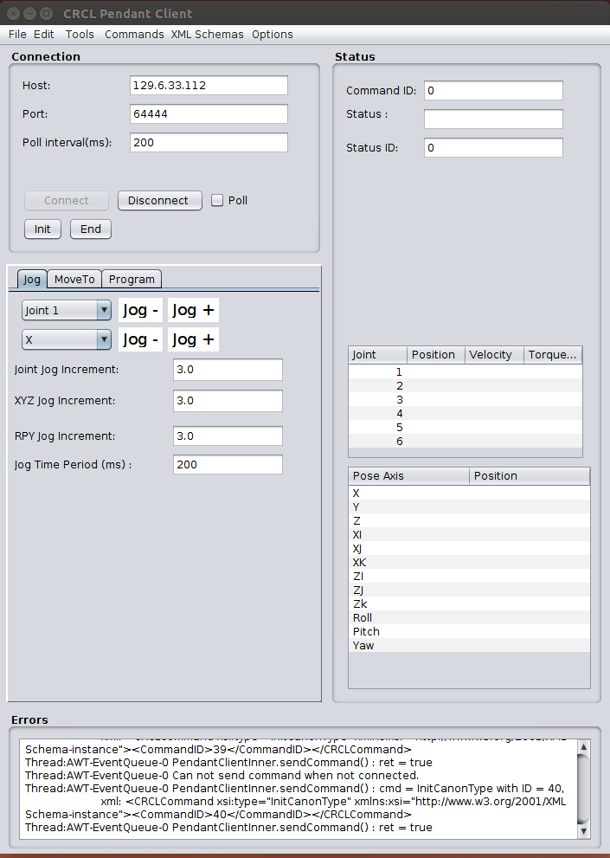

## URDF Xml Schema

ROS supplies a basic URDF schema file. It does not have any ../ Fixes were done to the urdf.xsd so that CodeSynthesis could compile it into a Cxx tree.

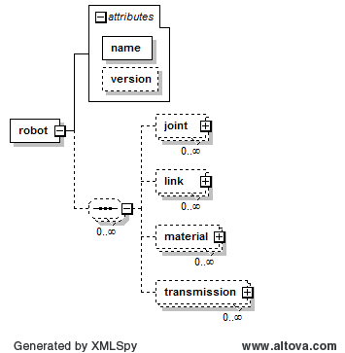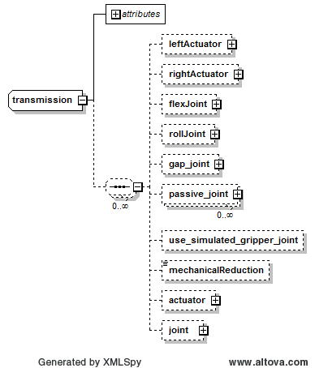

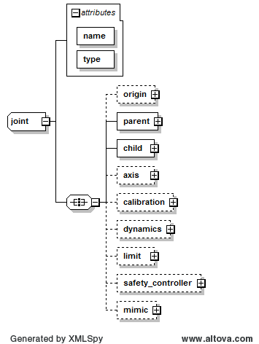

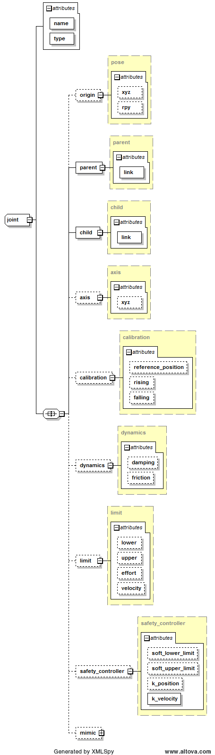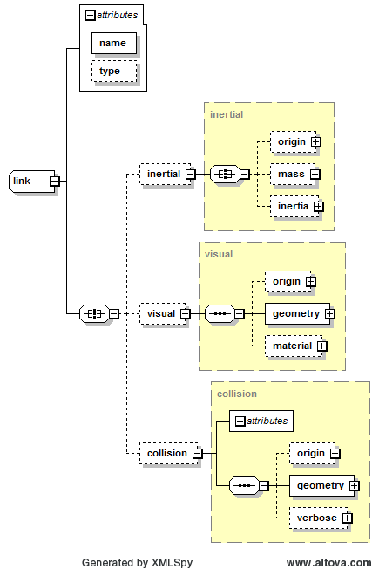

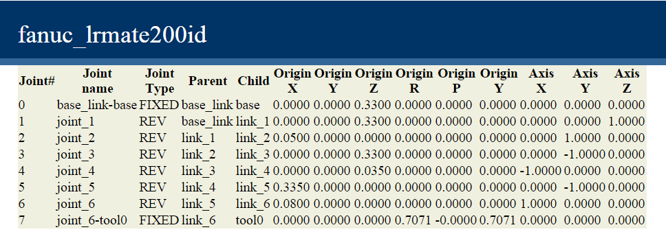

1. The x, y, z parameter corresponds to the origin xyz parameterws in the URDF Joint element.
2. The roll, pitch, and yaw parameters corresponds to the origin rpy parameter in the URDF Joint element.
3. The axis parameter define a unit vector pointing along the axis of rotation. For example, joint_1 rotates around the z axis. While joint_2 rotates in a negative direction around the y axis.



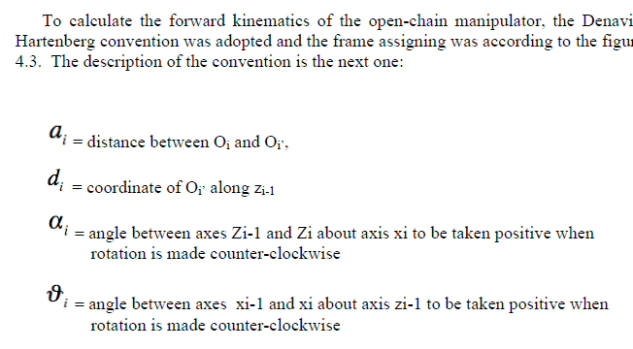

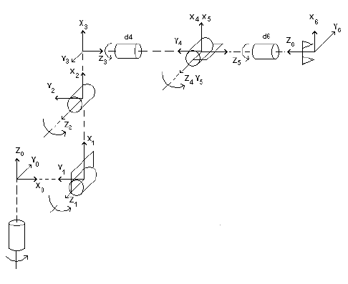



## Installing Descartes ROS package dependencies

cd ~/catkin_ws/src

git clone <https://github.com/ros-industrial-consortium/descartes.git>

Copy repositories from <https://github.com/ros-industrial?page=1>:

fanuc

fanuc experimental

motoman

ros industrial core

<https://github.com/ros-industrial-consortium>

descartes

[descartes_tutorials](https://github.com/ros-industrial-consortium/descartes_tutorials.git)

Exchanging Fanuc lrmate 200id for Motoman in Descartes demo

Copy file *lrmate200id_sim.launch* into folder:

/home/michalos/catkin_ws/src/descartes_tutorials/descartes_tutorial_support/launch

Then run:

roslaunch descartes_tutorial_support lrmate200id_sim.launch

File lrmate200id_sim.launch contains:

<?xml version="1.0"?>

<launch>

<arg name="sim" default="true" />

<include file="$(find fanuc_lrmate200id_moveit_config)/launch/moveit_planning_execution.launch">

<arg name="sim" value="$(arg sim)"/>

</include>

</launch>

# Linux Tips

Find a file recursively:

michalos@rufous:~/catkin_ws/src/motoman$ find . -type f -iname "*launch"